**Data set**

General HR information gathered from HR information system 1

A.Employee ID:unique employee record number

B.Position:Role the employee held

C.DOB:date of birth of the employee

D.Gender:employee gender(male/female)

E.Marital status of the employee:single/married/divorced/widowed

F.Date of hire:date when the employee was hired by company

G.Date of termination:if the employees has been terminated ,the date on which they were terminated or the last official working day

H.Termination:the reason why the employee left the organization

I.Employement status:wether the employee is currently with the company,terminated for a reason,or they themselves

Performance and employee satisfaction survey results gathered from the HR information system 2

A.Employee id:unique employee record number

B.Dept:which hdepartment the employee worked in-admin/executive office,etc

C.Manager name:employees manager name

D.Perf.score:most recent employee performance rating-exceeded expectations/met expectetions/improvement needed are generally moved towards a performance improvement program in which they are monitered for about 3-6 months after which a decision is made wether to continue to employ them let them go depending on the performance during the improvement program.

E.Employe.sat:employee satisfaction score-rating given by the employee on how much they are satisfied with their employement with the company.the survey is conducted once a year in a confeditial way.A rating of one means the employees is highly satisfied.However it is noticed that the employees very rarely gave a score of 1 or 2.

F.Date of the last perf:date on which the most recent performance was conducted.

G.Lare days:how many days the employee came late to work in the last one month time

H.Absent days:how many leave days the employee availed in the last one year

Employee salary details gathered from the financial information system

A.Employee id:unique employee record number

B.Salary:annual salary of the employee in USD

1. **Preparing the data for Tableau**

Before conducting any analysis in tableau, we need to first connect the data and see if there are any issues in the data set and then clean it up.

**Connecting:**

The data connection steps are given below

1. Connect tableau by selecting Connect 🡪 To a file 🡪Microsoft Excel 🡪Select file and open

2. In this case, since all sheets have equal number of rows and the employee ID is available in all sheets, we can do any type of join or data blending or combine using relationships

3. We will combine using relationships

4. Since HRIS-1 is the sheet that contains most information, we will bring it first to the tables section. Tableau will automatically use Employee ID to connect the tables. Close the window and move forward to connect the sheet FIS



5. Final data model should look like this



1. **Data clean up**

In this case, the data is quite clean. We will do a couple of steps to make the data more usable for future analysis. This involves creating grouping the data and creating hierarchies.

* 1. 1. Termination reasons are quite detailed. So, we will group them into some high-level groups. Note that this grouping is subjective and everyone would come up with a different grouping depending on how they would analyze
  2. a. *Career issues:* Career change, found a better job, went for higher paying job
  3. b. *Personal issues:* Did not return from maternity, health, higher education, relocated, sabbatical
  4. c. *Personnel issues:* Absconded, attendance, legal issues, misconduct, performance issues, Unhappy
  5. 2. Positions are also quite many in the dataset. It would be worthwhile to bring in the hierarchy here so that it makes more sense in the analysis. For instance, we can group the positions into senior management, middle management and employees
  6. a. *Senior management:* CEO / CIO/ Directors
  7. b. *Middle management:* Anyone with having ‘Manager’ in their job title
  8. c. *Employees:* everyone else

1. *Employment status:* we will combine ‘terminated for cause’ and ‘voluntarily terminated’ as one group called ‘terminated’.
2. We will rename the original ‘Employment status’ field as ‘Termination type’. This will allow use to nest the two fields employment status and termination type together if we want.

2**. Visualizing HR Data at Acme**

We will prepare the charts and dashboards in the order of expectations laid out. Note that there is no one way in terms of what charts need to be used.

**Group size and demographics**

1. **How many employees are currently employed by each department?**

● Move *Dept* to rows and *HRIS-1 (count)* to columns

● Move *Employment Status* to filter and filter ‘*Active employees’*

● Show text labels

● Sort the bar chart in the descending order

**Insight:**

The largest department is Operations with 116 employees, followed by IT, Sales, Admin, Software engineering and Executive office with 40, 26, 7, 7, and 1 employee respectively.

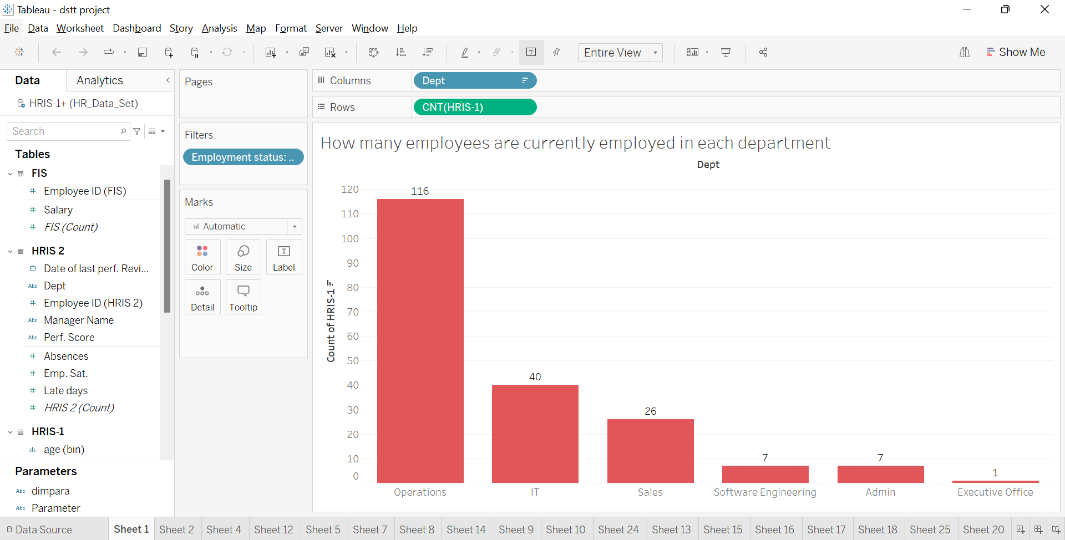

1. **What are the demographics of the current employees by age?**

● Create a calculated field called ‘Review Date’ with text ’31-Dec-2020’

● Create a calculated field to compute age (‘Age’) with the following calculation:

**ROUND(([Review date]-[DOB])/365,0)**

This computes the days between date of birth and the review date, converts it into years and then rounds off to the nearest year.

● Create bins for the field ‘*Age’* with a bin size of 10 years

● Bring ‘*Age (bin)*’ to columns and HRIS-1 (Count) to rows

● Filter for active employees

**Insight:**

The age group with most number of employees is 30 – 40 years with 96 employees followed by 40 – 50 years, 50 – 60 years, 20 – 30 years and then finally > 60 years with 59, 30, 7 and 5 employees respectively.

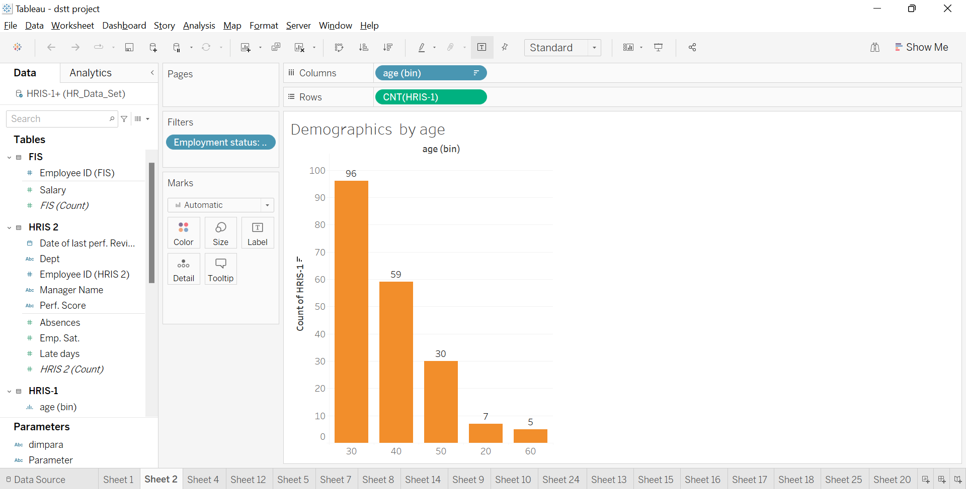

3) **What are the demographics of the current employees by Gender?**

● Bring Gender to rows and HRIS(Count) to columns

● Filter for active employees

● Enable text labels

**Insight:**

The company has more females than male employees – 113 and 84 respectively

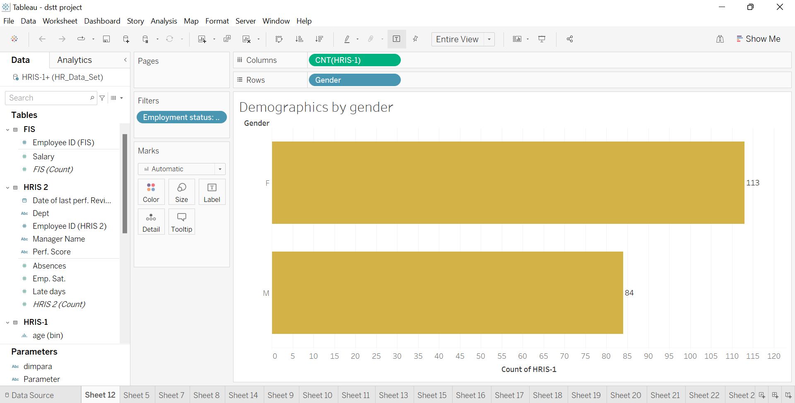

4) **What are the demographics of the current employees by Marital Status?**

● Bring Marital status to rows and HRIS(Count) to columns

● Filter for active employees

● Enable text labels

**Insight:**

Most of the employees are single – 97, followed by married, divorced, and widowed – 72, 24, and 4 respectively.

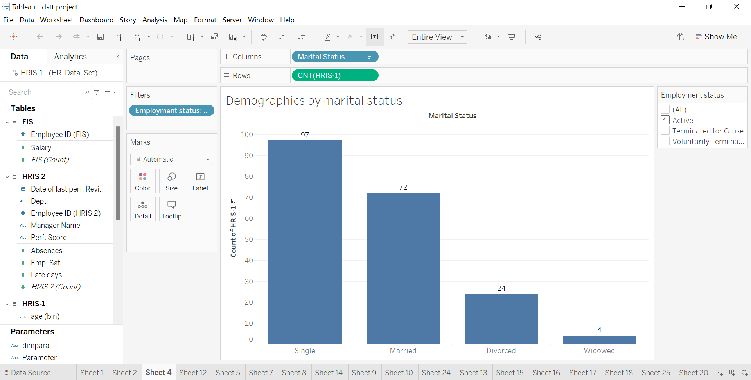

**Salary Structure**

1) What was the current total salary expense for each department?

● Bring Dept to rows and Salary to columns

● Duplicate the Salary field in the columns and convert the aggregation to ‘Avg’

● Filter for active employees and enable text labels

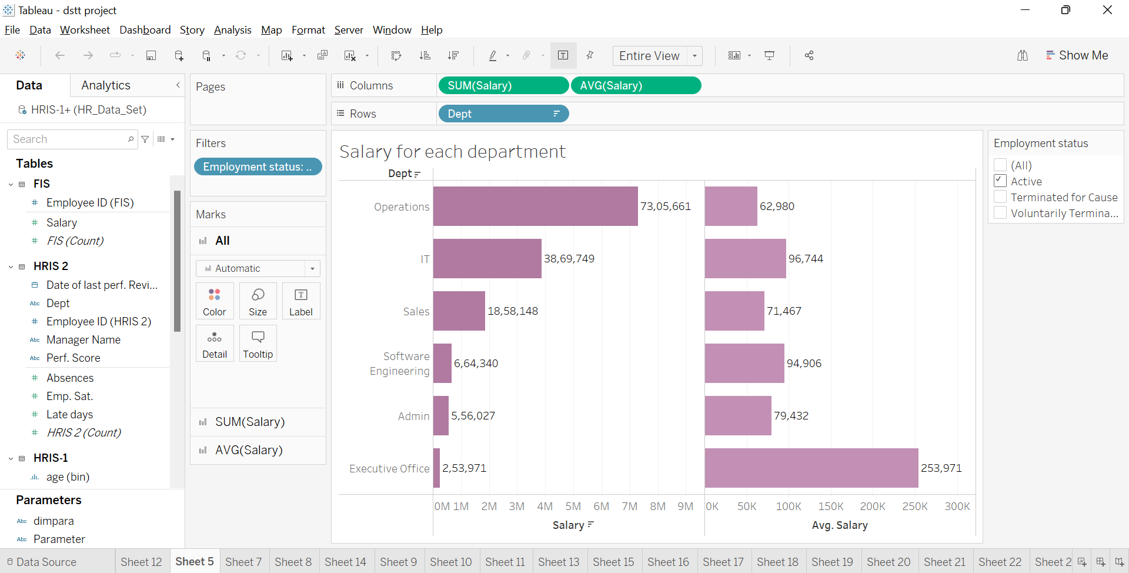

**Insight:**

Among all departments excluding executive office, given it is the CEO, the department with average highest salary is IT and the department with the lowest average salary is Operations. However, in terms of the total salary expenses, Operations is on the top mainly because of the number of the employees in the department.

2) What is the salary structure by Age?

● Bring the Age (bin) to the columns and salary to the rows

● Duplicate salary in the rows and convert aggregation to Avg

● Filter for active employees and enable text labels

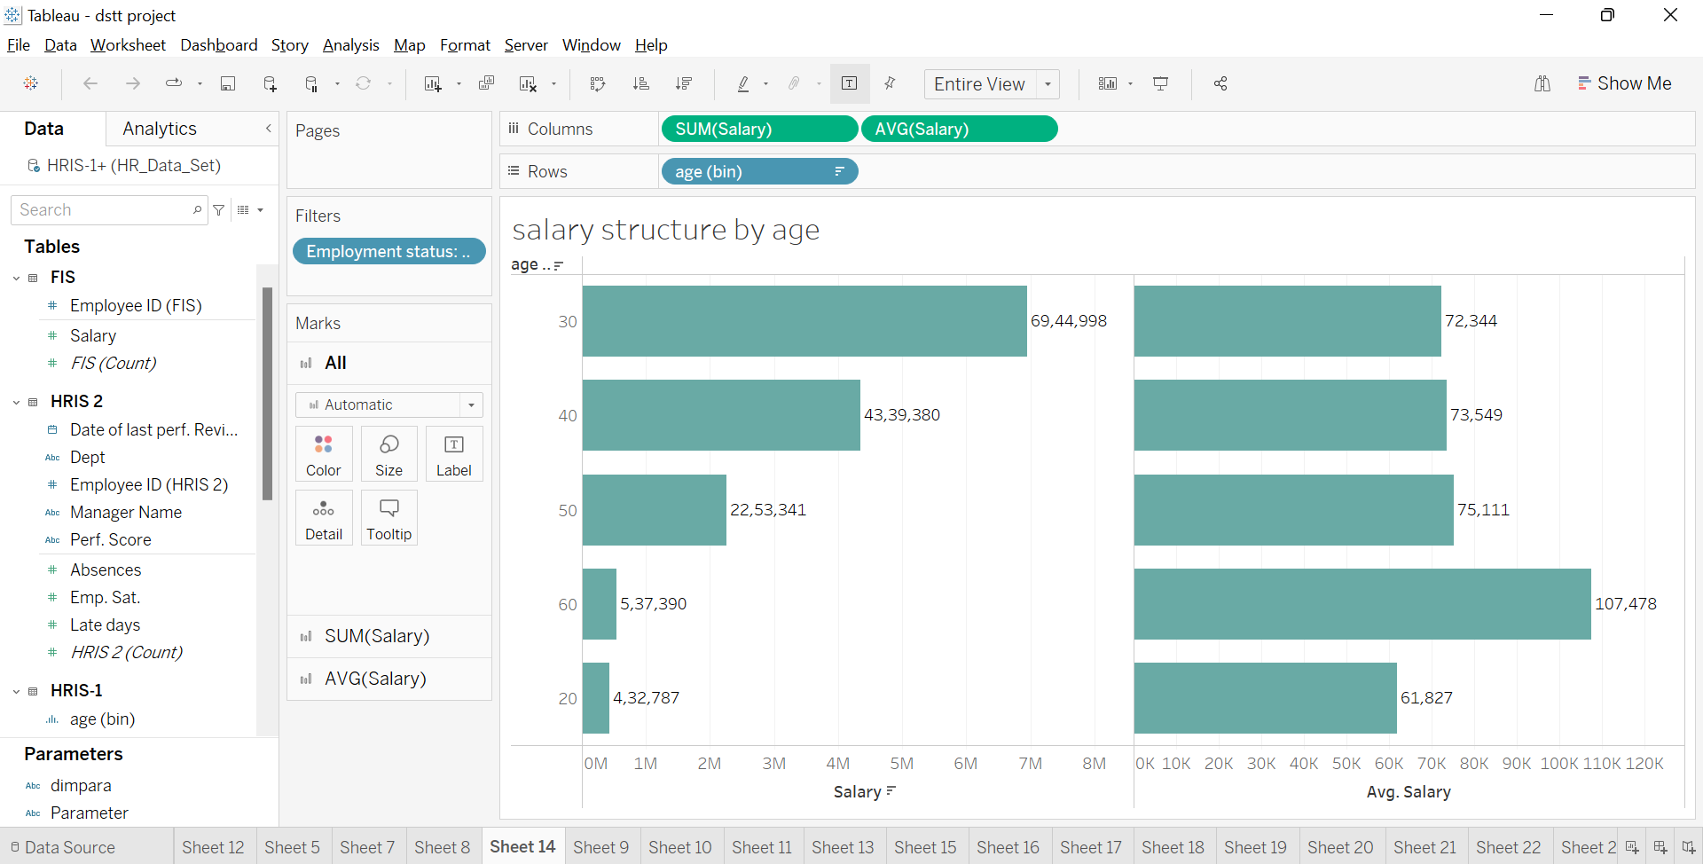

**Insight:**

In terms of average salary, across all bins the salary levels were similar except the 20 – 30 year bucket and 60+. This is mostly because there are only few employees in the bucket. However, in terms of total expense, the highest expense is in the 30 – 40 year category mainly because of the number of employees in the group.

3) What is the salary structure by Gender?

● Bring Gender to the rows and Salary to the columns

● Duplicate Salary in the columns and convert the aggregation to show Avg

● Filter for active employees and show the text labels

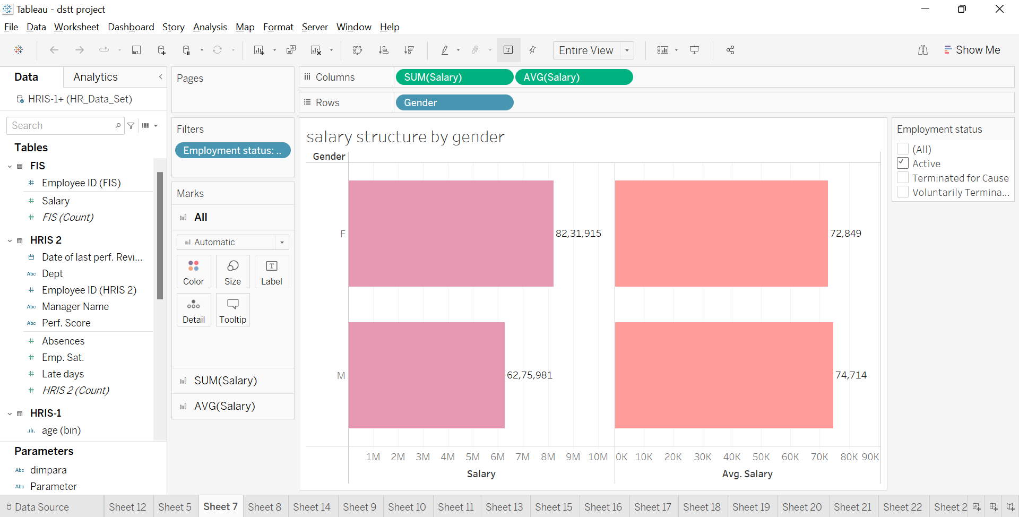

**Insight:**

More salary expense goes to the female gender mostly due to the number of female staffs. In terms of the average salary, the difference in the salary made by female staff in comparison with that of the male staff is about < $2000.

4) What is the salary structure by Marital Status?

● Bring Marital Status to the rows and Salary to the columns

● Duplicate Salary in the rows and convert the aggregation to show Avg

● Filter for active employees and show the text labels

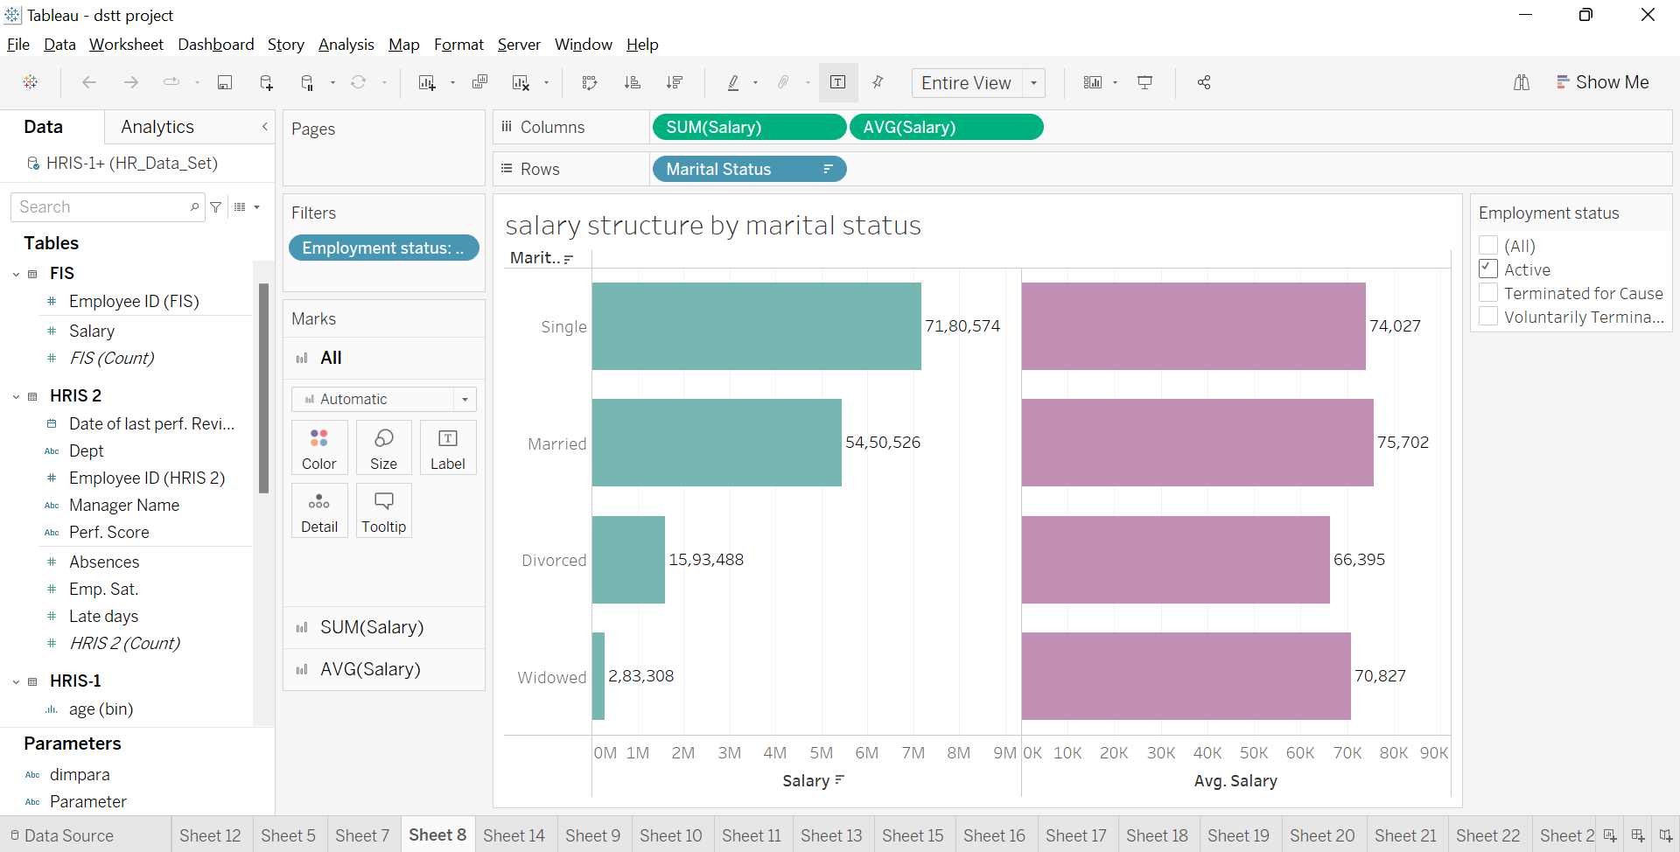

**Insights:**

It seems like the average salaries made by single and married employees were similar however the divorced employees made ~$8000 lesser. This could possibly because this category has only few employees however given that there are 24 employees in this group, we cannot disregard the difference in average salary.

**Performance Results:**

1. What was the distribution of employees in terms of their performance?

● In order to create a distribution of employees by performance, bring ‘Perf. Scores’ to columns and HRIS (Count) to the rows

● Filter for active employees and show the text labels

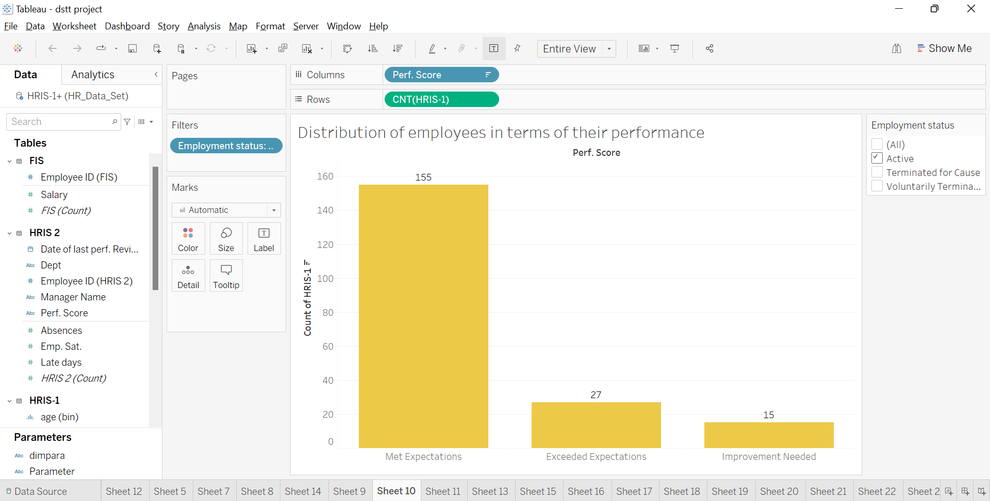

**Insights:**

We see the most(155)employees met the expectations,while 27 empoyees exceeded the expectations and 15 employees did not meet the standards and had to improve their performance.

2)Performance by Department

We will create a table using parameters to show the performance by different dimensions

● Bring ‘Perf Score’ to the columns and DimSelectControl to rows

● Include the HRIS(count) in the text

● Select Dept from the parameter control

● Filter for active employees

Duplicate this and include table calculation in the text to show the % total across rows

Bring these two charts to a new dashboard to analyse together

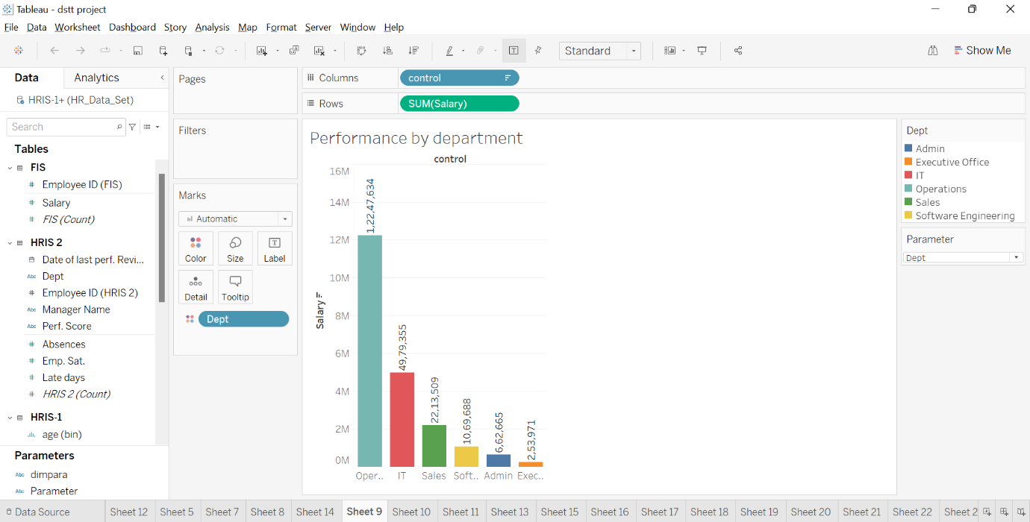

**Insight:**

We see that department operations has highest performance(1,22,47,634)results and IT department has next highest performace results and the next highest performance results are in sales department and

1. Performance by Manager Name

● Update the parameter and calculated field for parameter control to include the ‘Manager name’

● From the parameter control, select ‘Manager Name’

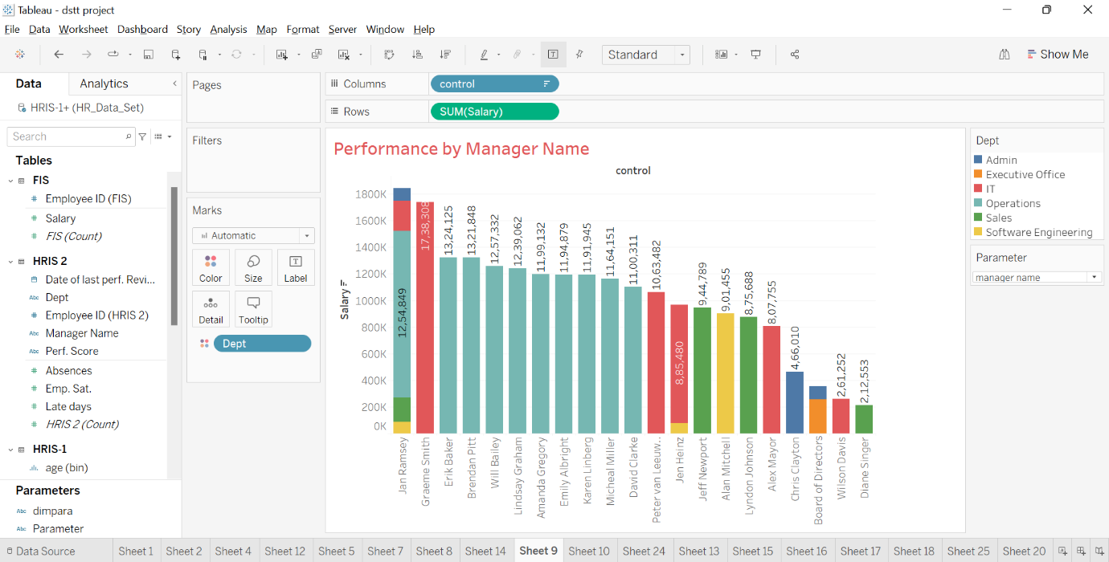

**Insight:**

Jan Ramsey gives the best performance among all the others.Next Graeme smith gives the best performance.Wilson Davis and Diane singer gives the least performance than others.

1. Performance by Age

● In order to create a distribution of employees by performance and age, bring ‘Age (bins) to columns and HRIS (Count) to the rows, bring ‘Perf Scores’ to the color. We could also use the cross table created earlier.

● Include table calculation Change the HRIS (count) to show % total

● Filter for active employees and show the text labels

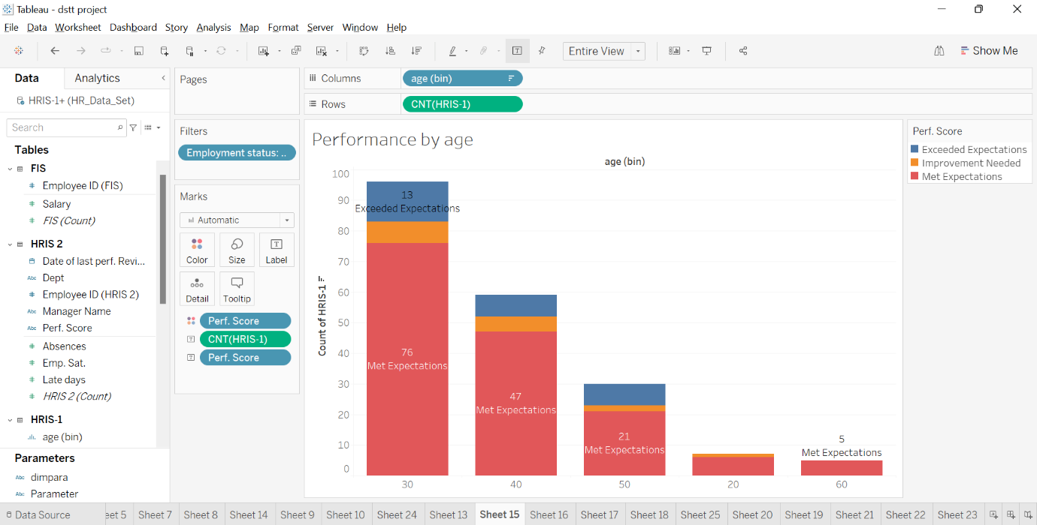

**Insight:**

In the age 30,76 members met expectations and 13 members exceeded expectations and 7 members needed improvement.In the age 40,47 members met expectations and 5 members needed improvement and 7 members needed improvement.In the age 50,21 members met expectations and 2 members needed improvement and 7 members exceeded expectations.In the age 20,6 members met expectations and 1 people needed improvement and no people exceeded expectations.In the age 60,5 members met expectations and no people needed improvement and no people exceeded expectations.

1. Performance by Gender

● From the dashboard created earlier, select ‘Gender’ from the parameter control

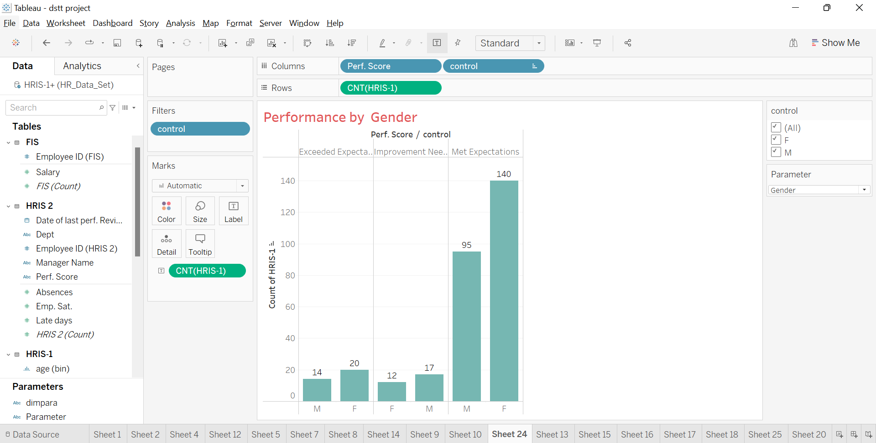

**Insight:**

14 males and 20 females exceeded expectations.12 females and 17 males needed improvement and 95 males and 140 females met expectations.

6) Performance by Marital Status

● From the dashboard created earlier, select ‘Marital Status from the parameter control

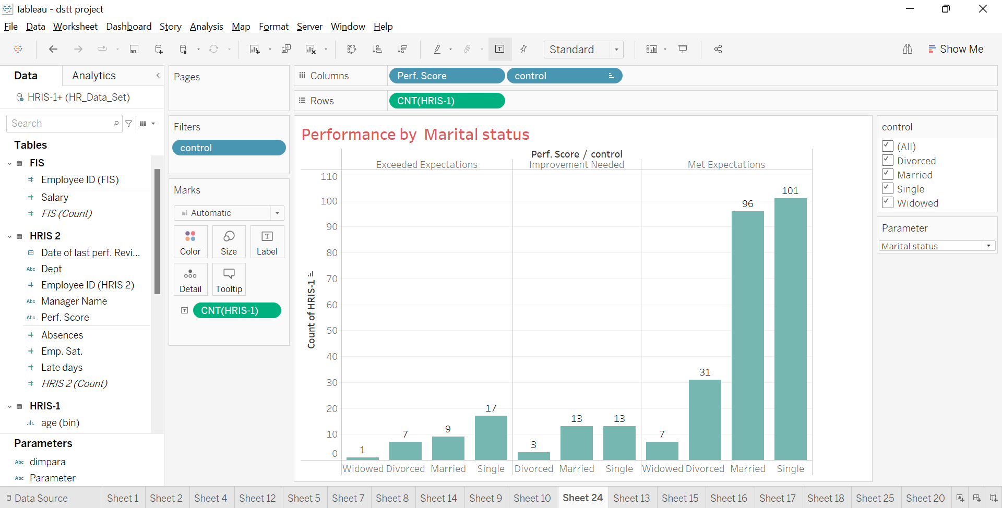

**Insight:**

1 widowed,7 divorced,9 married and 17 singles exceeded expectations.3 divorced,13 married and 13 single needed improvement.7 widowed,31 divorced,96 married and 101 singles met expectations.

7) Performance by Position

● From the dashboard created earlier, select ‘Position’ from the parameter control

